29.3: a) 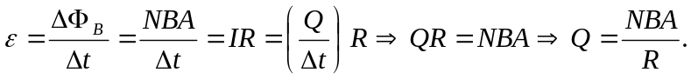
b) A credit card reader is a search coil.
c) Data is stored in the charge measured so it is independent of time.

